🏥 AI Implementation Blueprint
Patient Readmission Predictor (30-Day Readmission)
1. Problem Analysis & Business Context
Business Problem
Hospitals are penalized when patients are readmitted within 30 days of discharge. These penalties come from policies such as the Centers for Medicare & Medicaid Services Hospital Readmissions Reduction Program.
High readmission rates indicate:
- Poor discharge planning
- Inadequate follow-up care
- Medication issues
- Social determinants of health
Objective
Develop an AI system that predicts which patients are likely to be readmitted within 30 days so hospitals can provide preventive interventions.
Examples of interventions:
- Follow-up appointments
- Medication review
- Home care support
Expected Impact
Metric | Expected Outcome
Readmission rate | Reduced by 10–20%
Healthcare costs | Significant savings
Patient outcomes | Improved recovery
Resource allocation | Targeted support for high-risk patients
2. Why AI is Needed
Traditional rule-based systems cannot capture complex relationships in patient data.
AI can analyze:
- Medical history
- Comorbidities
- Medication patterns
- Previous hospital visits
- Lab test results
- Demographics
- Social factors
This allows early identification of high-risk patients.

3. Data Sources
Structured Data
Data Source | Examples
Electronic Health Records | diagnoses, procedures
Hospital visits | admission/discharge history
Lab tests | blood pressure, glucose
Medications | prescriptions
Demographics | age, gender

Unstructured Data (Optional)
- Doctor notes
- Discharge summaries
These can be processed with NLP models.

4. Data Pipeline & Architecture
AI System Architecture
Hospital EHR System
│
▼
Data Ingestion Layer
(API / Batch Processing)
│
▼
Data Warehouse / Data Lake
│
▼
Feature Engineering
- Comorbidity index
- Prior admissions
- Medication count
│
▼
Machine Learning Model
(Readmission Prediction)
│
▼
Risk Score Output
│
▼
Hospital Dashboard
(Alerts for doctors)

Technologies
Component | Technology
Data storage | SQL / Data Lake
ETL | AWS Glue / Spark
Model training | Python (Scikit-learn, XGBoost)
Deployment | API service
Visualization | Power BI / Tableau

5. Model Selection
The model must be interpretable because doctors need to trust the prediction.
Candidate Models
Model | Pros | Cons
Logistic Regression | Highly interpretable | Lower accuracy
Decision Trees | Easy to explain | Can overfit
Random Forest | Higher accuracy | Less interpretable
XGBoost | Excellent performance | Less transparent

Recommended Approach
Two-layer model strategy:
Primary model:
XGBoost → best predictive power
Interpretability layer:
SHAP values for explanations
This allows doctors to see why a patient is high risk.

Example explanation:
Patient risk = 72% because:
- Prior hospitalization (high impact)
- Diabetes
- Age > 70
- High medication count

6. Evaluation Strategy
Important Insight
Accuracy is NOT the right metric.
If only 10% of patients are readmitted, a model predicting "no readmission" gets 90% accuracy.
Instead we use:
Metric | Why
Recall | Catch high-risk patients
Precision | Avoid false alarms
F1 Score | Balance precision/recall
AUC-ROC | Model discrimination
Confusion Matrix | Clinical understanding

Priority Metric
Recall (Sensitivity)
Hospitals prefer:
Catch more high-risk patients even if some false positives occur.
Example:
Metric | Target
Recall | > 80%
Precision | > 60%
AUC | > 0.80

7. Ethical Risk Assessment (Week 2)
Healthcare AI systems can introduce bias.
Major Risks
1️⃣ Bias Against Demographics
If training data contains bias, predictions may discriminate against:
- Race
- Gender
- Socioeconomic status
2️⃣ Data Privacy
Healthcare data is regulated under Health Insurance Portability and Accountability Act (HIPAA).
3️⃣ Automation Bias
Doctors might blindly trust the AI recommendation.

Mitigation Strategies
Risk | Mitigation
Bias | fairness audits
Privacy | encrypted data
Transparency | explainable AI
Human oversight | doctor review required
Example fairness test:
Compare model performance across groups:
- Male vs Female
- Age groups
- Ethnicity

8. Build vs Buy Analysis
Option 1: Build In-House
Pros
- Custom model
- Full control
- Data security
Cons
- Expensive
- Requires AI team

Option 2: Buy Vendor Solution
Examples include:
- Epic Cognitive Computing
- IBM Watson Health
Pros
- Faster deployment
- Proven tools
Cons
- Limited customization
- Vendor lock-in

Recommended Approach
Hybrid Strategy
Buy:
- infrastructure
Build:
- predictive model

9. Proof-of-Concept (PoC)
A simple PoC demonstrates feasibility.
Example Dataset
Use publicly available hospital dataset:
- Diabetes readmission dataset
Features:
- Age
- Length of stay
- Number of medications
- Prior admissions
- Diagnoses

Sample Python Workflow
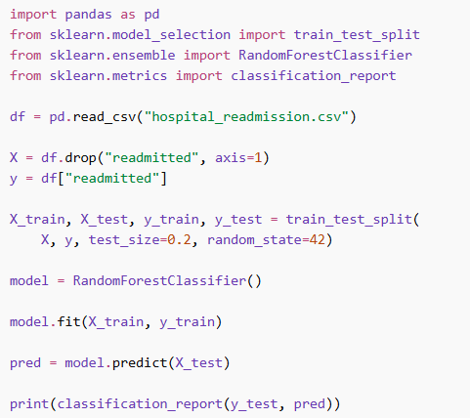
PoC Goal:
Show the model can predict readmission risk score.

High-Level Project Plan (4 Weeks)
Week | Activity
Week 1 | Data exploration & problem definition
Week 2 | Model development
Week 3 | Evaluation & ethics audit
Week 4 | Final architecture + presentation

11. Final Deliverables
The final presentation should include:
1️⃣ Problem analysis
2️⃣ Data pipeline architecture
3️⃣ Model selection justification
4️⃣ Evaluation metrics
5️⃣ Ethical risk analysis
6️⃣ Build vs Buy decision
7️⃣ Proof-of-concept demo

✅ Conclusion
An AI-powered readmission predictor can help hospitals:
- reduce penalties
- improve patient care
- allocate resources effectively
However, the system must prioritize:
- interpretability
- fairness
- privacy
- clinical oversight
SHAP Values
SHAP values are a method used to explain machine learning model predictions. They show how much each feature contributes to a prediction for a specific instance.
The method is based on Shapley Value from Game Theory, which distributes credit among players in a cooperative game. In machine learning, the “players” are the features of the model.

1. Simple Intuition
Suppose a model predicts:
Patient readmission risk = 72%
SHAP explains why the model predicted 72%.
Example explanation:
Feature | Impact on Prediction
Age > 70 | +12% risk
Previous hospitalizations | +20% risk
Diabetes | +8% risk
Short hospital stay | −6% risk

